As an admin it has been another good year.
There is a great deal happening in websites, in coding and tools for creating websites.
We have an up to date website at this time,
The Site is working well
Our hosting has performed faultlessly,
Thanks to Tom Waterhouse and we Know I. T.
I would like to Thank Rob hall and Anne Kempe for all their help to redo all the files and Links , for help reorganising menus and editing and for proofing of text and research for the site.
Most of my activity this year has centred around learning more about WordPress, making improvements to site speed and to research and add editing tools to the site.
The load speed has been progressively improved from 24secs to 5.2 secs. 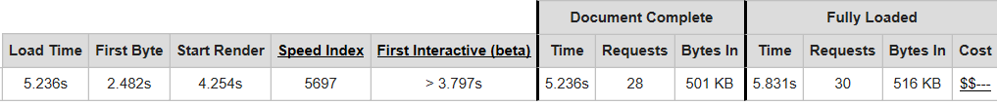 I have added a cache, removed a couple of plugins that were out of date and I hope we have made it a good site to visit and find Community Information.
I have uploaded a few new themes for testing
and
loaded , a few different plugins, css optimiser, editing tools, fonts and a cache
Also I have been looking at some of the really good new themes that are available.

A word about WordPress.org
Wordpress have completely updated much of the Core code for word press and that does account for a some of the improvements to the speed.
The documentation and support for WordPress is Immense.
Some items are:-
- The wordPress Website is https://codex.wordpress.org/
- A help Page https://codex.wordpress.org/Help:Contents
- There is a forum https://wordpress.org/support/
- http://www.wpbeginner.com/ beginning WordPress website,
- Torque Magazine https://torquemag.io/faces-of-wp/streamline-workflow-wp-cli/
- There are Volunteer coding groups
- There is an Adelaide WordPress meetup and PHP meetup group & similar worldwide.
- WordPress camps.
- All from an open source code and the dedication of the WordPress Founders..

Everyone is getting better at information Technology.
There is of the order of thousands of hours of orderly and innovative coding being done by groups like:- WordPress Drupal, Joomla , Weebly , Wix and dozens of other third party developers.

A little on themes
The Wordpress 2017 theme is a tutorial in itself and gives editing access to the template, content, CSS and other files that make up that theme.
The Text in comments within the content file (PHPcode and text) encourages the editing of the files.
The theme comes set-up with a fixed background and scrolling pages and widgets.
Nisarg theme
It functions in a similar fashion to the 2017 WP theme and is really worth looking at this theme http://www.mtloftycommons.lenswood-forestrange.org.au/

Elegant themes have produced
Divi 3.0 Theme and Visual Page Builder. This is a paid theme $8/ Mth for an individual.
which has :-
- Over 300,000 downloads.
- 46 drag and drop Elements ( templates) Contact form Slider Image Testimonial. Drop thm where you want then resize and edit
- You can write text/edit direct to the page no edit screen all on the spot editing colours resize texts paragraph video etc
- theme names 20 of. Café , elegant , interior(shop front display), bookin Agency.
- Build your own theme from scratch.
- Unlimited sites
- Dedicated support
I hope that you find the report not only a good read but a useful reference
Thank You.
Mall Drew Admin 2010-2017 <->

